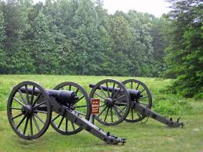

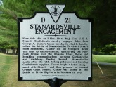

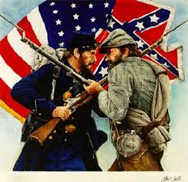

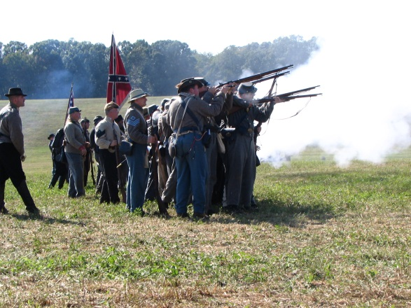

Stanardsville 2016
April 23rd and 24th

Located just off Blakey Ave
Stanardsville, Va 22973

Schedule of Events
Saturday:
8:00 am –Reveille
9:00am- Camps Open to Public/Dress Parade
9:15-9:45 am-Confederate Company Drill/Firing Evolutions
10:00-10:30am-Game of Rounders (Reenactors and Public can participate)
11:00-11:30-Union Company Drill/Firing Evolution
11:30-12:00pm-Civilian Demonstration on Sutler Row
12:00-12:30-Period Cooking Demonstration at the 7th Va Camp Site
12:30-1:30-Period Music
1:00pm-First Call for Reenactors
1:15-1:30pm-Union and Confederate Formation and Weapons
2:00-3:00pm-Battle of Stanardsville
3:00-4:00pm-Period Music
4:00-4:30pm-Mail Call
4:30-5:00pm- Civilian Demonstration on Sutler Row
5:00pm-Camps Close to the Public

Sunday ;
8:00am- Reveille
9:00am-Camps Open to the Public/Dress Parade
9:15-9:45am-Union and Confederate Company Drill
10:00-11:00am-Church Service(All Reenactors and Public Welcome)
12:00-12:30pm-Ladies Social
12:15pm-First Call for Reenactors
1:00-2:00pm-Offical Muster of the 7th Va Co. F
3:00pm- Camps close to Public

